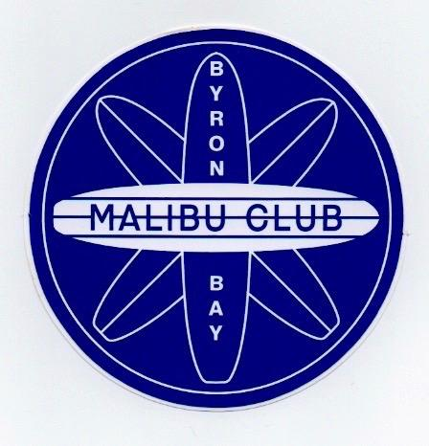 | The Byron Bay 42st Annual  Malibu Classic  Saturday 29th Sunday 30th of April 2023 |  | 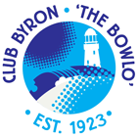
- Age as at 28th of April 2023  - Entry fee $80.00 per division ($55.00 for a second division if second T-Shirt not required) |  | - All boards must be 9ft or over with a single fin .  - A professional judging panel will be used

Email entry form with payment to:
The secretary byronbaymalibuclub@gmail.com
Electronic Payment: Account Name The Malibu Club Byron Bay Inc, BSB 122701, Account 23389733.
Include your name on bank reference and email your entry form.

Accommodation Enquiries: Club Byron Cabins 66856202
www.visitbyronbay.com/accommodation

✂
DIVISIONS  □ Open 9ft  □ Over 40  □ Over 60  □ Open Women  □ Over 40 Women  □ Open Old Mal  □ Over 40 Old Mal  □ Women’s Loggers |  |  |  |  |  | □ Over 50  □ Over 70  □ Men’s Loggers  □ Juniors - Entry Fee $40  □ Big Boys (100kg and over)
Name
Address
DOB |  |  |  | Phone Number
Email Address

T-shirt Size
Men’s: | □ S | □ M | □ L | □ XL | □ XXL | □ XXXL
Women’s | □ 8 | □ 10 | □ 12 | □ 14 | □ 16

I agree to release the Byron Bay Malibu Club Inc, the organisers, officials and all affiliated groups, all sponsors and any other parties from any liability, loss and damage (of whatsoever nature and howsoever arising) incurred whilst travelling to and from, or participating in or being present at the above mentioned event. I understand that all judges’, officials’ and organisers’ decisions are final and that no correspondence will be entered into. Competitors under 18 years of age must have their entry signed by a parent or guardian.

Signature: Parent/Guardian Signature (if under 18)

